**EN3510 Assignment 02 - Index no: 200740V (Github :** [oshanyalegama/EN3160-Assignment-01 (github.com)](https://github.com/oshanyalegama/EN3160-Assignment-01))

**1)**This question involves detecting blobs in a sunflower field image. This was done by convolving the image with a Laplassian of Gaussian filter as follows:

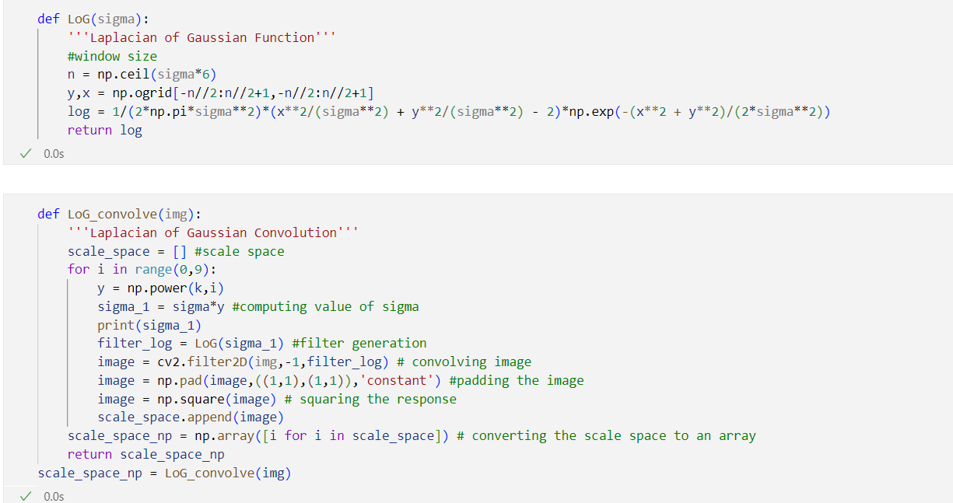

The blobs can be found by looping over the scale space and finding the local extremums.

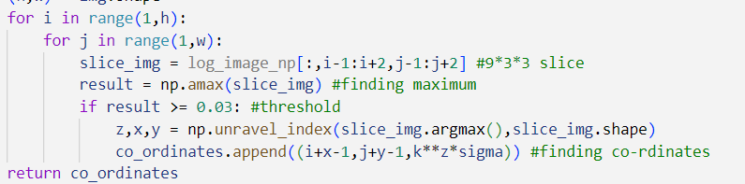

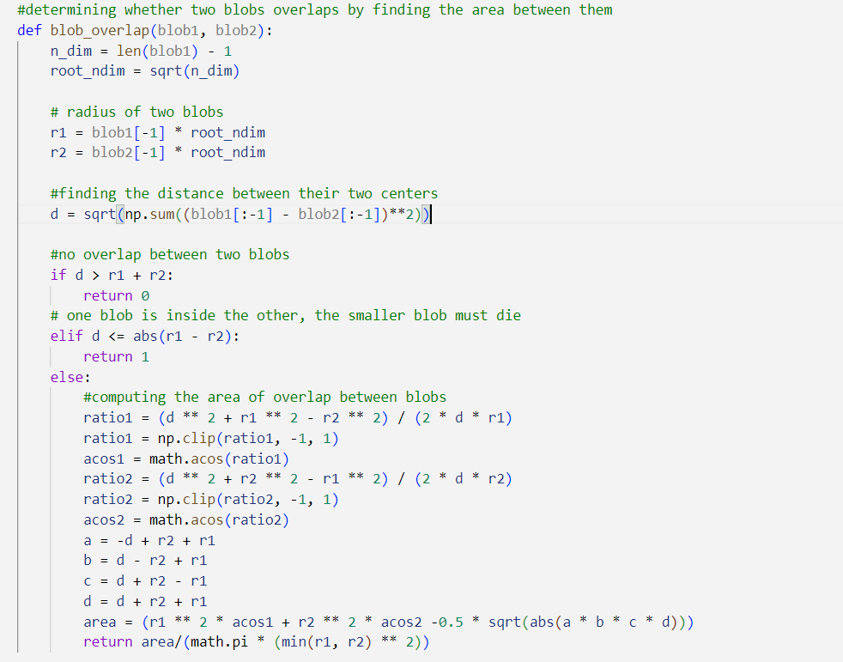For the sake of clarity, overlapping blobs were removed by the following code:

The resulting image with the blobs drawn using cv2.circle is given below:

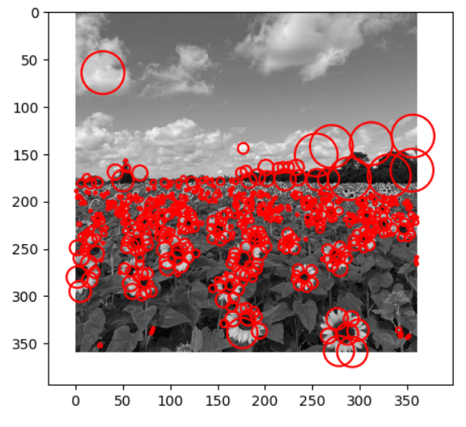

**2** a) Estimating the line using the RANSAC method. Number of points in the consensus was picked to be 0.4*(total number of points).

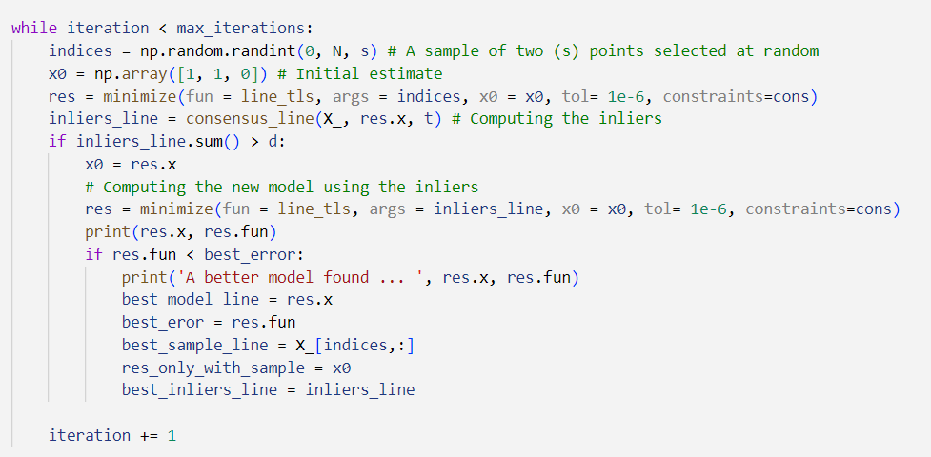

The line was that was finally drawn is as follows:

2 b) Estimating a circle from the remnant. 2 c) And finally the circle and

This can be done using the same code line both in the same graph.

but using s = 3 instead.

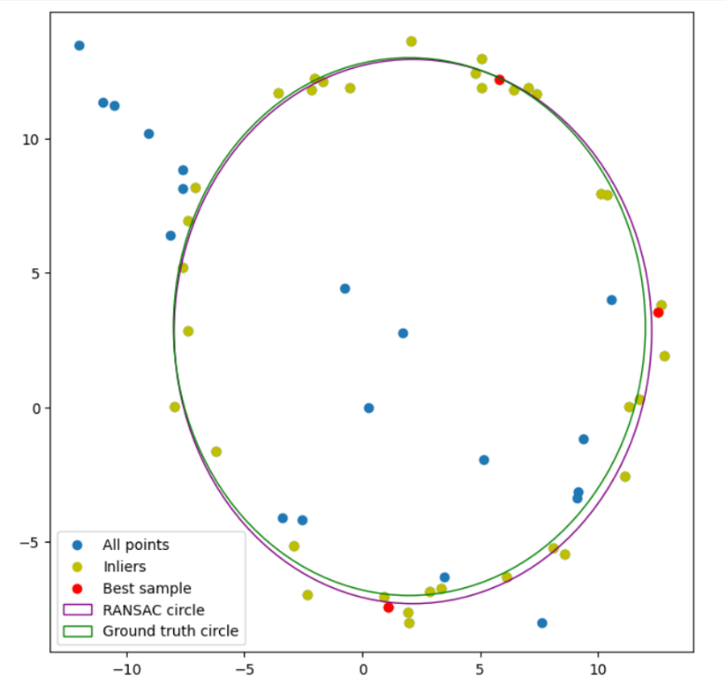

2 d) If we try to fit the circle first, due to higher number of degrees of freedom of the circle, a circle with an incredibly large radius might be fitted in which the dataset will only fit a small portion of its circumference.

**3)** Superposition can be carried out using the following functions.

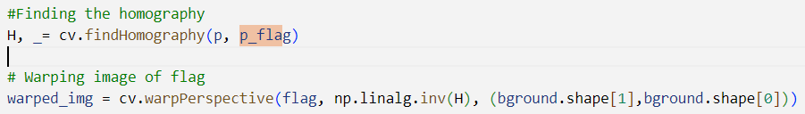

The source image, the overlapped image and the final image can be shown as follows.

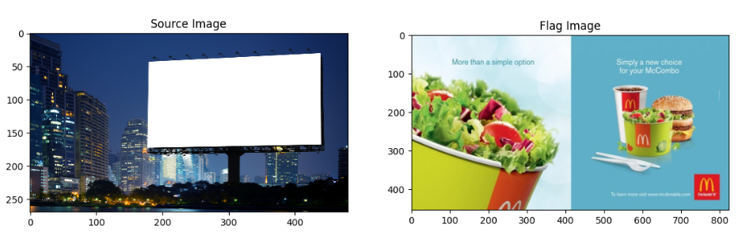

as given

**4)** The functions used for the question were sift_match, homography, RANSAC_homography and dist respectively. The code for their implementation is given below.

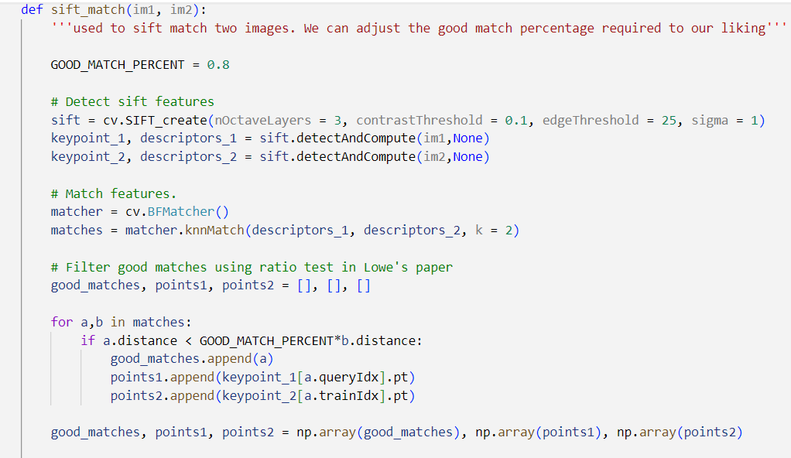

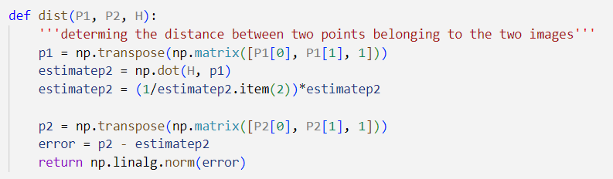

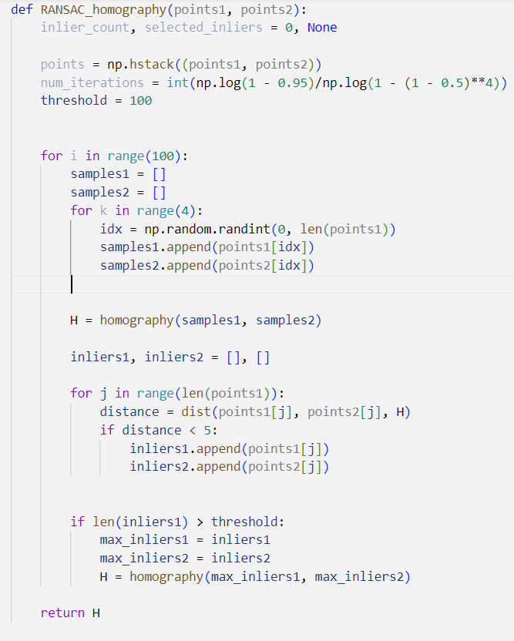

4 a) The matched features of the two images is as follows.

4 b) The computed homography is as follows:

[[-3.88187650e-01 -1.25070136e+00 3.79707045e+02]

[-5.46530342e-01 -1.73649073e+00 5.34220004e+02]

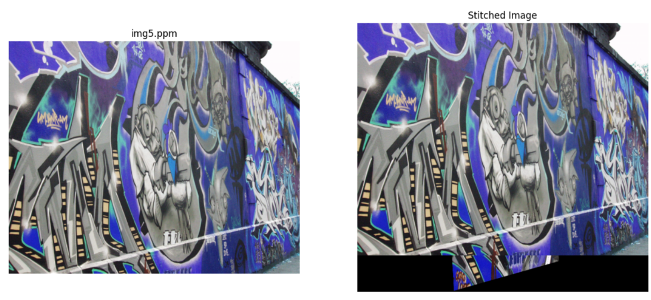 [-1.00077993e-03 -3.35899949e-03 1.00000000e+00]]

4 c) The stitched image is as follows.